JAVASCRIPT EXTRA NOTES (1)
1. C/C++ vs JavaScript Memory Management
Video ki shuruat mein ye bataya gaya hai ki C aur C++ mein memory management programmer ko khud karna padta hai (MALLOC/FREE ya NEW/DELETE se). Lekin JavaScript mein ye Automatic hota hai.
- Myth (Galatfami): Bahut se log sochte hain ki kyunki JS mein automatic memory management hai, toh yahan Memory Leak nahi ho sakta.
- Sach (Reality): JS mein bhi memory leak hota hai agar aap poore (ghatiya) tarike se code likhte ho. Isliye iska concept samajhna bahut zaroori hai.
2. Memory Management Kyu Zaroori Hai?
Memory infinite (aseemit) nahi hai. Hamare program ko RAM mein jagah milti hai.
- Agar aapne bahut saari memory occupy kar li aur use release nahi kiya, toh aapka program Slow ho jayega, Hang karega ya fir Crash ho jayega.
- Program tabhi efficient hota hai jab wo utni hi memory use kare jitni zaroori hai aur baki ko free kar de.
3. Stacks vs Heap (The Biggest Confusion)
Video ka sabse important part ye hai jahan (MySirG) ek bada "Blunder" (galti) point out karte hain jo bahut se log sikhate waqt karte hain.
A. Call Stack (Ya sirf Stack)
- Bohot se log bolte hain ki Stack aur Call Stack alag hain. Ye galat hai. Dono ek hi cheez hain.
- Kaam: Ye track karta hai ki abhi kaunsa function chal raha hai aur use kisne call kiya hai.
- Data Structure: Ye "Stack" data structure follow karta hai (LIFO - Last In First Out). Jo function call hota hai wo top pe aata hai, execute hone ke baad top se hat jata hai.
B. Heap
- Kaam: Heap ek badi unstructured memory area hai jahan Objects aur Functions store hote hain.
- Jab bhi aap koi object banate ho ya function define karte ho, wo "Heap" mein jaata hai.
4. Execution Context (The Foundation)
Ye ek set of information hai jo program chalte waqt memory occupy karti hai. Iske do types hain:
- Global Execution Context (GEC): Program shuru hote hi banta hai aur Call Stack mein sabse niche baith jata hai.
- Function Execution Context: Har function call par naya banta hai aur Stack ke top pe aata hai.
Execution Context ke andar 3 cheezein hoti hain:
- Lexical Environment: (Iska detail 22 mins ke thoda baad hai, lekin shuruat mein bataya gaya hai ki isme variables store hote hain).
- this keyword.
- Internal Metadata.
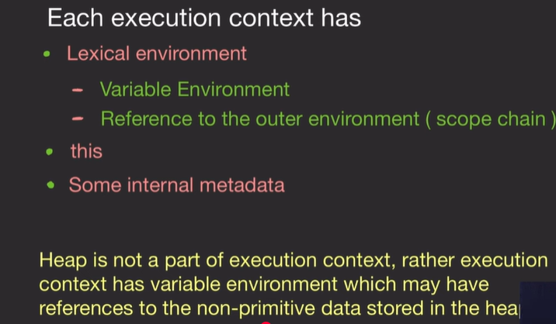5. Memory Allocation ka Asli Structure
Video mein ek bohot bada point clear kiya gaya hai: Heap, Execution Context ka part nahi hai.
- Execution Context "Call Stack" mein rehta hai.
- Call Stack ke andar "Variable Environment" (Jo ek Object-like structure hai) mein variables store hote hain.
- Jo Primitive types (number, string, boolean) hain, unki value directly Variable Environment mein store hoti hai.
- Jo Non-primitive types (objects, arrays, functions) hain, wo Heap mein rehte hain, aur unka sirf "Address" ya "Refernce" Variable Environment wale variables mein store hota hai.
Summary (First 22 Minutes):
- JS mein memory management automatic hai lekin programmer ko dhyan rakhna padta hai.
- Call Stack functions ka order aur order of execution manage karta hai.
- Heap objects aur functions ka bada storage hai.
- Program chalte hi Global Execution Context banta hai.
- Primitive values Stack mein (Variable Environment ke andar) rehti hain, jabki Objects Heap mein rehte hain aur Stack mein unka sirf pointer hota hai.

JAVASCRIPT EXTRA NOTES (2)
1. Execution Context ka Internal Structure
Video mein samjhaya gaya hai ki Execution Context ke andar jo Lexical Environment hota hai, uske do main parts hote hain:
- Variable Environment: Yahan saare variables aur functions store hote hain.
- Reference to Outer Environment: Ye wo "link" hai jo functions ko apne baap (parent scope) ke variables access karne deta hai.
2. JavaScript Code Execution ke Do Phases
Akshay ne bohot zor dekar samjhaya hai ki JS engine code ko ek baar mein nahi, balki do phases mein chalata hai:
- Phase 1: Memory Creation Phase
  - JS engine poore code ko upar se niche tak scan karta hai.
  - Variables (jaise var a) ke liye memory allocate karta hai aur unhe ek special value deta hai: undefined.
  - Functions ke liye wo poora ka poora function block uthakar memory mein rakh deta hai.
  - Important: Is phase mein code execute nahi hota, sirf memory reserve hoti hai.
- Phase 2: Code Execution Phase
  - Ab engine dobara line-by-line chalta hai aur actual values assign karta hai.
  - Jo a pehle undefined tha, ab wo 5 ban jata hai.
  - Functions ko jab call kiya jata hai, tabhi unka naya "Execution Context" banta hai.
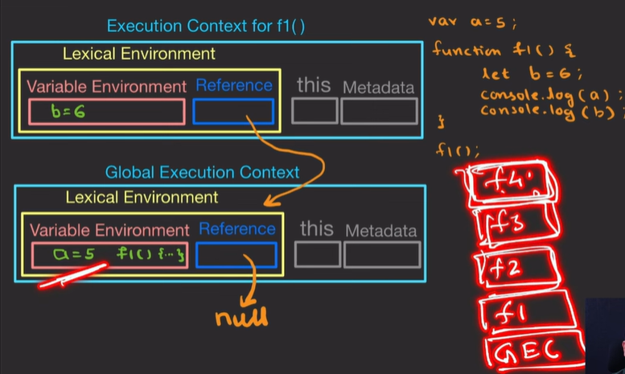3. Scope Chain aur Singly Linked List
Ye is video ka sabse technical part hai. Akshay ne bataya ki:
- Jab ek function (maano F1) ke andar koi variable nahi milta, toh wo apne Reference to Outer Environment ka use karke Global scope mein jaata hai.
- Ye jo "rasta" hai, ise computer science ki bhasha mein Singly Linked List data structure kehte hain.
- Interview Question: Interviewer pooch sakta hai ki Lexical Environment kaise implement hota hai? Aap bol sakte ho: "Singly Linked List ki tarah."
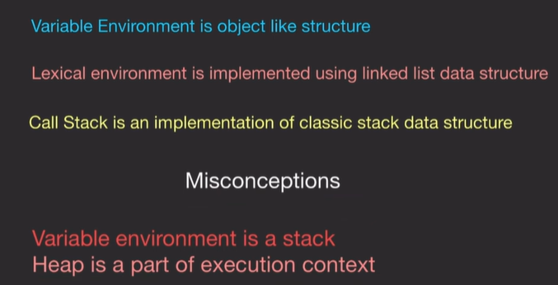4. Primitives vs Objects (Memory Location)
Akshay ne clear kiya ki memory milti kaise hai:
- Primitive Types (Number, String, Boolean): Inka size fixed hota hai, isliye ye directly Variable Environment mein store hote hain.
- Non-Primitive (Objects, Functions): Inka size badh sakta hai, isliye ye Heap mein store hote hain. Stack mein sirf inka Address (Pointer) rakha jata hai.
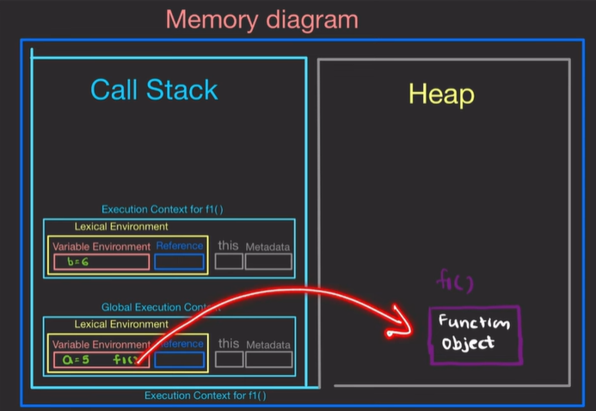
5. Garbage Collection (Automatic Safai)
Video ke aakhir mein Garbage Collector ka concept samjhaya gaya:
- Agar Heap mein koi aisa object pada hai jise ab koi bhi point nahi kar raha (matlab uska address kisi variable ke paas nahi hai), toh JS engine use "Kachra" (Garbage) maanta hai.
- JS engine automatically us memory ko free kar deta hai taaki program crash na ho. Lekin ye kab hoga, ye hum control nahi kar sakte.
6. Memory Leak se Bachne ke Tips
Akshay ne kuch aisi galtiyan batayi hain jo humein nahi karni chahiye:
- Global Variables avoid karein: Global variables program khatam hone tak memory occupy karke rakhte hain. Zyada global variables matlab zyada memory waste.
- SetInterval/SetTimeout: Agar aapne koi timer lagaya hai aur use clearInterval se band nahi kiya, toh wo memory leak kar sakta hai.
- Dangling References: Kabhi kabhi hum objects delete kar dete hain par unka reference kisi variable mein chhod dete hain, jiski wajah se Garbage Collector use saaf nahi kar pata.

Summary of the entire video:
- Memory Management: JS mein automatic hai (Garbage Collector ke zariye), par programmer ko dhyan rakhna padta hai.
- Execution Context: Call Stack mein push hota hai aur do phases mein kaam karta hai.
- Data Structures: Call Stack ke liye Stack, Lexical Environment ke liye Singly Linked List, aur Variable Environment ek Object-like structure hai.
- Foundation: Akshay ne kaha ki agar C/C++ ka base hai, toh ye concepts samajhna bohot asaan ho jata hai.

